Data Centre Infrastructure & Innovation Summit UAE (DCIIS UAE 2026)
Date: 29-30 June 2026
Location: Dusit Thani Dubai, UAE
My Experience
The Data Centre Infrastructure & Innovation Summit UAE 2026 provided me with a totally new way of looking at the technology that I use every day. Initially, my thoughts about technology were mainly from the point of view of the user, focusing on coding, websites, software and AI tools. It was at the summit that I came to appreciate the huge amount of underlying infrastructure that is responsible for making these technologies possible.
It was a 2 days Conference. I heard a number of industry leaders, engineers, policymakers, and researchers talking about the rapid expansion of the UAE's digital infrastructure in order to support artificial intelligence, cloud computing, and future technological development. The aspect that impressed me most was the huge amount of planning, engineering, and collaboration needed to set up and run modern data centers. Overall, the event underlined the UAE's ambition to become a leading centre for digital transformation as well as its commitment to sustainability and energy efficiency.

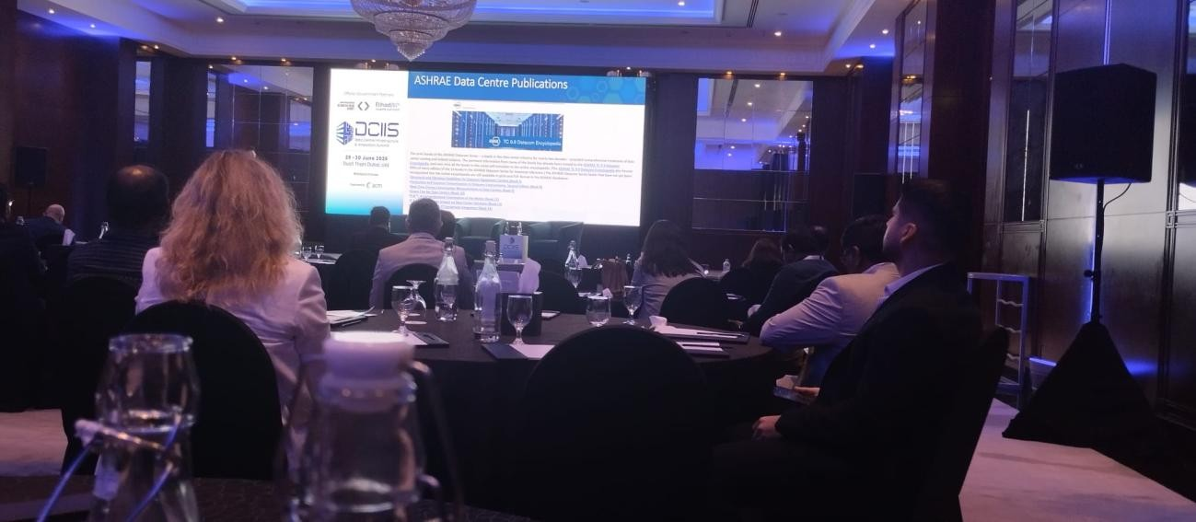

Key Learnings
One of the most important lessons I learned was that AI does not exist in isolation. Behind every AI model, cloud service, or digital platform is a network of powerful data centers that require careful design, reliable energy sources, advanced cooling systems, strong security measures and a plethora of other stuff!
I was particularly interested in discussions about sustainable infrastructure. Before attending the summit, I had never really considered the environmental challenges associated with large-scale computing. Learning about energy-efficient designs, sustainable construction, and innovative cooling technologies showed me how engineers are working to balance technological progress with environmental responsibility.
Other key points were about:
- The growing demand for data centers across the UAE and Middle East as AI and digital technologies continue to expand.
- How AI can be used to optimize operations and improve efficiency within datacentre environments.
- The importance of resilience, cybersecurity, and long-term planning for critical digital infrastructure.
Speakers
The atmosphere of the summit was professional, forward-thinking, and genuinely inspiring. One of the highlights for me was having the opportunity to hear directly from speakers such as H.E. Eng. Yousif Ahmed Al Ali, Eng. Mariam Al Ali, and representatives from Khazna Data Centers, Masdar City, and Heriot-Watt University. Listening to their panel discussions and insights was especially valuable because these are people actively shaping the future of digital infrastructure in the UAE and beyond.
As a student, it was honestly a little surreal to be sitting in the audience listening to experts whose decisions and projects operate on a scale that I had only previously read about online, but what I enjoyed most was seeing professionals from different industries come together around a shared ONE goal: building a smarter, connected, sustainable future. Despite their different backgrounds, they all emphasized similar values.
I’m particularly grateful for the opportunity to attend these sessions as I learn directly from people with such extensive experience. Beyond the technical knowledge I gained, the summit gave me a clearer picture of the kinds of careers, projects, and opportunities that exist within the technology sector.

Inspiration and Future Ideas
While I have previously focused on software, web development, and exploring AI tools, DCIIS showed me the infrastructure that makes these technologies possible. Learning about large-scale data centers, sustainable energy solutions, operational resilience and alot of more!
As I listened to the panel discussions, I noted down some project and research ideas to explore later. Some of these ideas have already been added to my personal "to-build" and research list.
- A Python dashboard that visualizes energy consumption and efficiency metrics for a simulated data centre.
- A data analysis project exploring how AI growth increases demand for computing infrastructure and energy resources.
- A small simulation model comparing the environmental impact of different cooling and energy strategies used in data centers.
- Research into how renewable energy sources can be integrated into large-scale digital infrastructure.
Although many of these projects (I might add more!) are still on my future goals list, I hope to gradually develop and expand them as I continue studying computer science and technology. This experience gave me new directions for my research/programming projects and future learning. Grateful to be part of this opportunity.

